PRACTICAL 5
Implement a producer-consumer communication system using anonymous pipes where the parent process generates data and the child process consumes it. Measure the communication efficiency.
Develop a program that executes the equivalent of the shell command: ls -l | grep ".c" using fork(), pipe(), dup2(), and exec() system calls.
5A) #include <stdio.h>
#include <stdlib.h>
#include <unistd.h>
#include <sys/wait.h>
#include <time.h>
#include <string.h>
#define BUFFER_SIZE 1024
#define DATA_SIZE 100000
int main() {
int pipefd[2];
pid_t pid;
char buffer[BUFFER_SIZE];
if (pipe(pipefd) == -1) {
perror("pipe");
exit(EXIT_FAILURE);
}
pid = fork();
if (pid < 0) {
perror("fork");
exit(EXIT_FAILURE);
}
if (pid > 0) {
// Parent = Producer
close(pipefd[0]);

char data = 'A';
int remaining = DATA_SIZE;
struct timespec start, end;
clock_gettime(CLOCK_MONOTONIC, &start);
while (remaining > 0) {
int chunk = remaining > BUFFER_SIZE ? BUFFER_SIZE : remaining;
char temp[BUFFER_SIZE];
memset(temp, data, chunk);
write(pipefd[1], temp, chunk);
remaining -= chunk;
}
close(pipefd[1]);
wait(NULL);
clock_gettime(CLOCK_MONOTONIC, &end);
double time_taken =
(end.tv_sec - start.tv_sec) +
(end.tv_nsec - start.tv_nsec) / 1e9;
double efficiency = DATA_SIZE / time_taken;
printf("\nProducer:\n");
printf("Data produced: %d bytes\n", DATA_SIZE);
printf("Communication time: %.6f seconds\n", time_taken);
printf("Communication efficiency: %.2f bytes/second\n",
efficiency);
}
else {
// Child = Consumer
close(pipefd[1]);
int total_read = 0;
int bytes_read;
while ((bytes_read = read(pipefd[0], buffer, BUFFER_SIZE)) > 0) {
total_read += bytes_read;
}
close(pipefd[0]);
printf("Consumer:\n");
printf("Data consumed: %d bytes\n", total_read);
}
return 0;
}
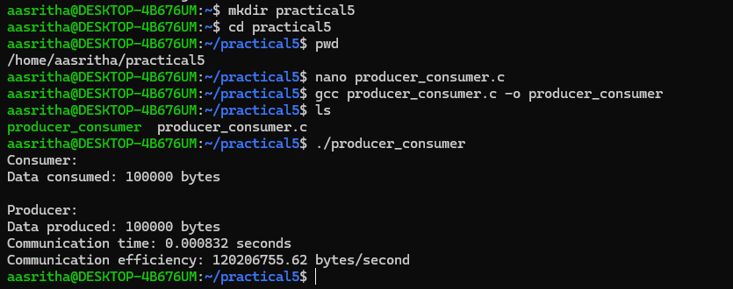
5B) #include <stdio.h>
#include <stdlib.h>
#include <unistd.h>
#include <sys/wait.h>
int main() {
int pipefd[2];
if (pipe(pipefd) == -1) {
perror("pipe");
exit(EXIT_FAILURE);
}
pid_t pid1 = fork();
if (pid1 < 0) {
perror("fork");
exit(EXIT_FAILURE);
}
if (pid1 == 0) {
// First child: execute ls -l
close(pipefd[0]);
dup2(pipefd[1], STDOUT_FILENO);
close(pipefd[1]);
execlp("ls", "ls", "-l", (char *)NULL);
perror("execlp ls");
exit(EXIT_FAILURE);
}
pid_t pid2 = fork();
if (pid2 < 0) {
perror("fork");
exit(EXIT_FAILURE);
}
if (pid2 == 0) {
// Second child: execute grep ".c"
close(pipefd[1]);
dup2(pipefd[0], STDIN_FILENO);
close(pipefd[0]);
execlp("grep", "grep", ".c", (char *)NULL);
perror("execlp grep");
exit(EXIT_FAILURE);
}
// Parent process
close(pipefd[0]);
close(pipefd[1]);
waitpid(pid1, NULL, 0);
waitpid(pid2, NULL, 0);
printf("\nCommand executed successfully.\n");
return 0;
}

